Mental Health - Lockdown Burnout?
Are you feeling burnt out? Tried, stressed, unable to sleep or unable to stay awake?
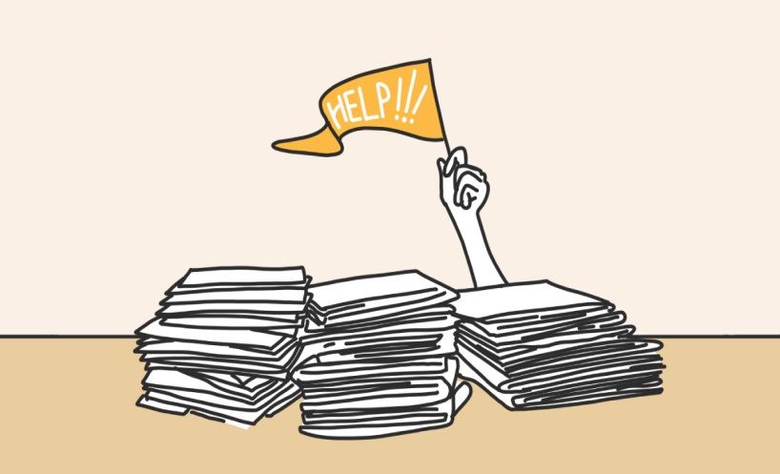
Quick clarification: as a term, ‘burnout’ is not neatly defined. Some use it as a catch-all for the result of the various stressors in a modern life; other, including the World Health Organisation, (WHO) as a purely work related issue. The signs of ‘burn out’ are:

- Having little motivation
- Finding it harder than normal to do normal tasks
- Having ‘brain fog’
- Finding it hard to concentrate
- Having a low mood

Here are some ideas to help you:

1 Separate work from rest
If you are working from home, it’s important to recognise that you don’t have the same boundaries anymore. While these were already blurred, thanks to emails on phones and the rest of it, this is now exacerbated, and, while before you may have broken up your day with things like going to get coffee, now, you might sit in front of your laptop and not move for nine hours. Break up your day: sit down to eat, make time for exercise, stop work at your normal time.

2 Create a routine
Rather than waking up each morning and creating it from scratch – decide what you are going to do – lay the day out ahead of you. This can help to lessen your mental load; even just knowing what you’re going to have for breakfast, that you are going out for a 30 minute walk or having a virtual coffee with friends.

3. Take time out
You may not want to ‘waste’ precious holiday days when a drive to your supermarket is all you can expect to fill them with. But breaks are still important – and you will get overloaded if you don’t give your brain a break from being continually ‘on’ and answerable to various people.

4 Limit your online meetings after a working day
Your social life is now probably more intense. In an after-work drinks scenario, you stop and go to the loo. In an online meeting scenario you are now staring at a bunch of other faces, with a teeny, yet jarring time lag and you may feel like everyone is looking at you, when you don’t actually know where gazes are directed. You may like to turn off the video occasionally. No one will think badly of you.

5 Understand how much is being asked of you
If you are a parent and are expected to perform your job to the level you always have, at the same time as keeping a toddler entertained and home schooling another child it may be time to lower your standards; you cannot do everything perfectly right now. Do not compare yourself to other people, everyone is different.

6 Do the things that make you feel good
Things like exercise, time with nature, talking to a friend and eating well all add up to the big, overarching sensations you go through. Is it possible for you to take time out to do something you enjoy early in the morning? Can you make sure that you connect with someone every day? Can you plan your menus?

7 Be compassionate
To others; to yourself, know that it’s unrealistic for you to be ‘amazing’ all of the time at this moment in time. Don’t be annoyed if you’re finding it hard to concentrate – research shows that this is to be expected.

Short Story – We are in a hard and difficult situation. Be gentle.

If you need any support at any time, please contact the Mental Health First Aiders.

